

Casa Convalescència – UAB CAMPUS Barcelona

Please read carefully the Reservation conditions before sending the reservation request:
Family name: Fist name:
University/Institution:
Mailing Address:
Country:
Telephone: Fax:
E-mail:
I wish to reserve: (please tick the appropriate box)
Hotel | Single Room* | Double Room* | FAX Number / email
1.Hotel Amrey Sant Pau**  C/St. Antoni Ma. Claret, 162 | 79,00€ | 98,00€ | +34 93 433 41 51  santpaureservas@grupoamrey.com
2.Hotel Bel Art****  C/Lepant, 406 | 102,00€ | 117,00€ | +34 93 433 43 69  reservas@hotelbelart.com
3.Hotel Abalon*  C/Cartagena, 369 | 61,00€ | 64,50€ | +34 93 435 81 23  abalon@mediumhoteles.com
4.Hotel Medicis**  C/Castillejos, 340 | 74,00€ | 89,00€ | +34 93 455 34 81  medicis@mediumhoteles.com
5.Hotel Aristol***  C/Cartagena, 369 | 77,50€ | 100,60€ | +34 93 433 51 01  aristol@mediumhoteles.com
Date of arrival:___/___/2005 Date of departure:___/___/2005 Number of nights:_____
*Price per room per night. Breakfast included. 7% TAX not included
Date of arrival:___/___/2005 Date of departure:___/___/2005 Nights:___
day / month day / month
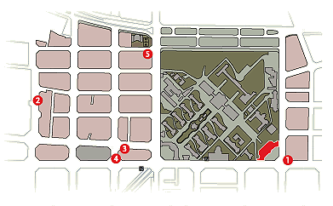Number of nights:_____ Name of the guests:____________________________
________________________________________________________________
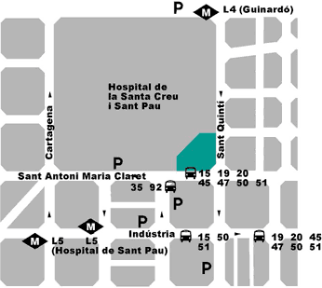
Please send this registration form to the corresponding hotel as soon as possible by FAX or email. The reservation will be confirmed upon availability on a first-come first-served basis.
Participants should pay the bill directly to the hotel on departure. Hotel will only confirm those reservations with full Credit Card details.
Credit Card Number:
Name Cardholder: Expiry date: ____/____/____
day / month / year
Date:____/____/____ Signature:
Day/month/year

